**OBSTACLE AVOIDING ROBOTIC SYSTEM**

**BY**

**DEPARTMENT OF MECHATRONICS ENGINEERING**

**GROUP 1**



**COLLEGE OF ENGINEERING**

**BELLS UNIVERSITY OF TECHNOLOGY-NEW HORIZONS**

**Team Members**

**Adebayo Timothy**

**Adebisi Damilare**

**Adegbuyi Korede**

**Adediran Adeyosola**

**Aseyori Abraham**

**(ICT 215)**

**SUBMITTED TO:**

**MR. AYUBA MUHAMMED**

**DECLARATION**

We hereby declare that this is the original work of Group 1 of the project design reflecting the knowledge acquired from Research on the 200L first semester Project about **Robotics E.D.A Development.** We therefore declare that the information in this report is original and has never been and has never been submitted to any other institution for any award other than Bells University Of Technology, Department Of Mechatronics Engineering, College Of Engineering, For evaluation in our test and Examination.

**Name: …………………………………………….**

**Signature: ……………………………………………..**

**Date: ……………………………………………**

**Name: …………………………………………….**

**Signature: ……………………………………………..**

**Date: ……………………………………………**

**Name: …………………………………………….**

**Signature: ……………………………………………..**

**Date: ……………………………………………**

**Name: …………………………………………….**

**Signature: ……………………………………………..**

**Date: ……………………………………………**

**Name: …………………………………………….**

**Signature: ……………………………………………..**

**Date: ……………………………………………**

**APPROVAL**

We have read and recommended this 200L first semester project design entitled “**Obstacle Avoiding Robotic System**” acceptance of Bells University in Total fulfillment of requirement of Test and Examination scores needed for our result.

……………………………………………………

**Ayuba Muhammed**

Lecturer

## ****ACKNOWLEDGEMENT****

We, Group 1 wish to express our profound gratitude to our supervisor for their invaluable guidance, constructive feedback, and unwavering support throughout the course of this project. Your mentorship has been crucial in shaping our ideas and ensuring the successful completion of this work.

We are also deeply appreciative of the contributions and dedication of all our group members. The teamwork, collaborative spirit, and shared commitment to achieving our goals have been instrumental in bringing this project to fruition. Design & Implementation of an Obstacles Avoiding Robot

Additionally, we extend our sincere thanks to our lecturers, whose expertise, encouragement, and dedication to imparting knowledge have provided us with the tools and insights needed to tackle the challenges of this project.

we are also grateful to our university for providing us with the resources, facilities, and an enabling environment to carry out this project successfully. This achievement is the result of the combined efforts and support of all those involved.

Finally, we would like to give thanks to GOD for his mercy and grace over our lives; for keeping us from the beginning of the project till the end.

**DEDICATION**

We dedicate this project to our able lecturer who gave his time and effort to the understanding of the concept of this course and also offered support during the course of this project. We also dedicate this project to the LORD almighty for the gift of life, his protection and provision. We wouldn’t have made it this far without him.

**TABLE OF CONTENT**

**CHAPTER ONE: INTRODUCTION**

**1.1**  Brief overview of obstacle avoidance robots

**1.2** Objectives and scope of the project

**1.3** Importance of obstacle avoidance in robotics

**CHAPTER TWO: LITERATURE REVIEW**

**2.1**  Overview of existing obstacle avoidance technologies

**2.2** Discussion on Arduino Uno and Proteus in robotics projects

**2.3** Comparison of different sensors for obstacle detection

**CHAPTER THREE: METHODOLOGY**

**3.1 Hardware Components:**

- Description of Arduino Uno microcontroller

- Explanation of sensors (ultrasonic, infrared, etc.) used for obstacle detection

- Motor driver and other hardware components required for robot movement

**3.2 Software Implementation:**

- Programming the Arduino Uno for obstacle avoidance

- Simulation of the robot in Proteus for testing

- Integration of sensor data for real-time obstacle detection

**3.3 Circuit Design:**

- Schematic diagrams of the robot circuitry

- Explanation of the connections between Arduino Uno, sensors, and motors

- Testing the circuit in Proteus for accuracy

**CHAPTER 4: DESIGN AND SIMULATION OF AN OBSTACLE AVOIDING ROBOT USING MATLAB**

**-**Introduction

**-**Literature Review

**-**Objectives

-System Architecture

-Tools and Technology

-Methodology

-MATLAB Simulation

-Results and Analysis

-Challenges and Limitations

-Future Work

-Conclusion

**CHAPTER 5: CONCLUSION**

**4.1** - Summary of the project

**4.2** Key findings and achievements

**4.3** Future work and potential enhancements

**REFERNCES**

**CHAPTER 1**

**INTRODUCTION**

1. **Brief Overview Of Obstacle Avoidance Robots**

An obstacle avoidance robot is an autonomous mobile robot designed to detect and maneuver around obstacles in its environment, ensuring safe navigation without human intervention. These robots are equipped with various sensors and control systems that allow them to perceive their surroundings and make real-time decisions about their movements.

**Key Features**

There are various components of an obstacle avoidance robot. Among those there are the necessary components needed for it to work. They are:

1. **Sensing Technology:**

Most obstacle avoidance robots utilize ultrasonic sensors, infrared sensors, or a combination of both to detect obstacles and measure distances. Ultrasonic sensors emit sound waves and evaluate the time it takes for echoes to return, while infrared sensors detect the presence of objects using light reflection.

1. **Microcontroller:**

The central processing unit, often based on platforms like Arduino or Raspberry Pi, processes data from the sensors, executes the control algorithms, and sends commands to the motors that drive the robot's movement.

1. **Actuators:**

The robot uses motors (DC, servo, or stepper) to facilitate movement, enabling it to travel forward, backward, or change directions when an obstacle is detected.

1. **Navigation Algorithm:**

The logic that determines how the robot behaves upon sensing an obstacle. Basic algorithms often involve immediate avoidance maneuvers, such as reversing or turning, while more advanced models may incorporate pathfinding techniques to navigate complex environments.

**Operation**

An obstacle avoidance robot operates in a loop: it continuously senses its environment, processes the sensor data to identify any potential obstacles, and then adjusts its movement accordingly. For example, if an obstacle is detected within a certain distance, the robot will halt or change direction to avoid a collision. This real-time feedback loop allows for dynamic navigation through various environments.

**Applications**

Obstacle avoidance robots are widely used in various fields, including:

1. **Home Automation:** Robotic vacuum cleaners that navigate around furniture while cleaning floors.
2. **Industrial Automation:** Automated guided vehicles (AGVs) in warehouses that transport goods safely.
3. **Search and Rescue:** Robots designed to navigate rubble and debris in disaster situations to locate survivors or assess damage.
4. **Educational Tools:** Used in robotics education to teach students about sensors, microcontrollers, and programming.

**Conclusion**

The obstacle avoidance robot serves as an excellent example of how robotics technology can enhance automation and improve safety in various applications. By integrating components like sensors and microcontrollers with sophisticated algorithms, these robots can operate autonomously and effectively navigate their environments, paving the way for advancements in robotics and automation.

1. **Objectives And Scope Of The Project**

**Objectives**

The primary objective of this project is to design and develop an obstacle avoidance robot using an Arduino UNO microcontroller and simulation software like Proteus. The specific objectives include:

1. **Design and Construction:**

Create a functional prototype of an obstacle avoidance robot that can autonomously navigate around obstacles

1. **Microcontroller Programming:**

Develop and implement a robust control algorithm using Arduino IDE to process sensor data and control the robot’s movements effectively.

1. **Sensor Integration:**

Utilize ultrasonic sensors (such as the HC-SR04) to detect obstacles and determine their distance, allowing for real-time adjustments in navigation.

1. **Simulation and Testing:**

Employ Proteus software to design and simulate the circuit, ensuring proper integration of hardware components and software algorithms before physical implementation.

1. **Performance Evaluation:**

Test the robot’s performance in various environments to evaluate its ability to detect and avoid obstacles efficiently. Analyze the results to identify areas for improvement.

1. **Documentation:**

Prepare a comprehensive project report that includes design specifications, programming code, testing procedures, results, and conclusions. This documentation will serve as a valuable reference for future projects.

**Scope of the Project**

The scope of the obstacle avoidance robot project encompasses the following aspects:

* 1. **Component Selection:**

The project will focus on using widely available and cost-effective components such as Arduino UNO, ultrasonic sensors, motor drivers (like the L298N), and basic servos or DC motors for movement.

* 1. **Simulation Environment:**

The Proteus software will be used to design and simulate the robot’s electronic circuitry, allowing for easy troubleshooting and visualization of the system’s operation.

* 1. **Limitations of the Robot:**

The robot will be designed for basic navigation tasks in a controlled environment, such as a flat surface with common household obstacles. Complex navigation in unpredictable or unstructured environments like outdoor terrains is outside the project’s scope.

* 1. **Learning Outcomes:**

The project aims to enhance understanding of fundamental concepts in robotics, microcontroller programming, sensor integration, and circuit design. It serves educational purposes for the students involved.

* 1. **Future Recommendations:**

Although this project focuses on basic obstacle avoidance, recommendations for future enhancements may include incorporating advanced algorithms (such as machine learning), wireless communication, and expanded functionality (e.g., pathfinding capabilities).

* 1. **Potential Applications:**

Discuss potential real-world applications of the developed robot, such as in the fields of robotics research, education, and basic industrial automation. The project will also explore the potential for scaling up and integrating more sophisticated features in future iterations.

**Conclusion**

The objectives and scope outlined are intended to guide the development of the obstacle avoidance robot, ensuring a structured approach to learning and creation. By focusing on key aspects such as sensor integration and software simulation, this project aims to provide valuable insights into the principles of robotics and foster skills in problem-solving and design.

1. **Importance Of Obstacle Avoidance In Robotics**

Obstacle avoidance is a critical aspect of robotics, enabling robots to navigate safely and efficiently through various environments. The ability to detect and avoid obstacles is essential for ensuring the robot's safety, preventing damage, and maintaining operational effectiveness.

**Key Importance of Obstacle Avoidance**

1. **Safety:**

The primary importance of obstacle avoidance lies in preventing accidents and ensuring the safety of people, the robot itself, and the surrounding environment. By avoiding collisions, robots can operate without causing harm or damage.

1. **Efficiency:**

- Obstacle avoidance enables robots to navigate through complex environments without manual intervention, allowing for more efficient operation and completion of tasks. This is particularly crucial in applications where continuous operation is required, such as manufacturing or logistics.

1. **Autonomy:**

The capability to avoid obstacles autonomously is fundamental for the development of truly autonomous robots. It allows robots to make decisions based on their environment, enhancing their ability to perform tasks independently.

1. **Reliability:**

By avoiding obstacles, robots can reduce the risk of mechanical failure or damage, thereby increasing their reliability and lifespan. This is especially important in applications where maintenance access is limited or expensive.

1. **Adaptability:**

Obstacle avoidance algorithms enable robots to adapt to changing environments. This adaptability is crucial for robots operating in dynamic settings, such as outdoor terrains or environments with moving objects.

**Applications Where Obstacle Avoidance is Crucial**

Obstacle avoidance is crucial in the following areas

**1. Industrial Robotics:**

In manufacturing and warehouse management, obstacle avoidance is vital for robots to navigate safely among machinery, inventory, and human workers.

**2. Service Robotics:**

Robots designed for service tasks, such as cleaning, delivery, or assistance, require obstacle avoidance to operate effectively and safely in public or domestic environments.

**3. Autonomous Vehicles:**

The ability to avoid obstacles is fundamental for self-driving cars and drones, ensuring safe navigation through complex traffic scenarios and unpredictable environments.

**4. Search and Rescue Operations:**

Robots used in disaster response must be able to navigate through rubble and debris, avoiding obstacles to locate survivors or assess damage efficiently.

**5. Space Exploration:**

Robotic vehicles in space exploration need sophisticated obstacle avoidance systems to navigate unfamiliar terrains safely, ensuring the success of missions and the preservation of costly equipment.

**Conclusion**

Obstacle avoidance is a foundational element of robotics, underpinning the safety, efficiency, autonomy, reliability, and adaptability of robotic systems. As robots become increasingly integrated into various aspects of life, from industrial settings to personal assistance, the importance of obstacle avoidance will only continue to grow, driving innovation and advancement in the field of robotics.

**CHAPTER 2**

**LITERATURE REVIEW**

1. **Overview Of Existing Obstacle Avoidance Technologies**

Obstacle avoidance is a critical function in robotics, enabling robots to navigate safely and efficiently through various environments. Several existing technologies contribute to this capability, each with its own strengths and limitations. This overview highlights some of the key technologies used in obstacle avoidance:

**1. Ultrasonic Sensors**

**Principle:** Emit sound waves and measure the time it takes for echoes to return.

**Advantages:**

* Simple implementation
* Low cost
* Compact size

**Disadvantages:**

* Limited accuracy
* Vulnerable to noise and interference
* Limited range

**2. Infrared (IR) Sensors**

**Principle:** Detect changes in temperature or radiation patterns.

**Advantages:**

* + Low cost
  + Compact size
  + Suitable for short-range applications

**Disadvantages:**

* + Limited range
  + Vulnerable to interference from light sources
  + May not detect obstacles behind reflective surfaces

**3. Lidar (Light Detection and Ranging)**

**Principle:** Emission of laser light and measuring the time-of-flight for returned pulses.

**Advantages:**

* + High accuracy
  + Long range
  + Robust against environmental changes

**Disadvantages:**

* + High cost
  + Complex implementation
  + Potential for interference from other laser sources

**4. Camera-Based Vision Systems**

**Principle:** Using cameras to detect objects and obstacles based on visual cues.

**Advantages:**

* + High accuracy
  + Long range
  + Robust against environmental changes

**Disadvantages:**

* + Complex implementation
  + Sensitive to lighting conditions
  + May require extensive processing for object recognition

1. **Stereo Vision Systems**

**Principle:** Using two cameras to calculate depth information.

**Advantages:**

* + High accuracy
  + Robust against environmental changes
  + Suitable for indoor applications

**Disadvantages:**

* + Complex implementation
  + Sensitive to lighting conditions
  + May require extensive processing for object recognition

**6. Radar and LiDAR Sensors**

**Principle:** Using radio waves or laser to detect the speed and distance of objects.

**Advantages:**

* + Long range
  + Robust against environmental changes
  + Suitable for various applications

**Disadvantages:**

* + High cost
  + Complex implementation
  + May not provide detailed depth information

**7. Sensor Fusion**

**Principle:** Combining data from multiple sensors to achieve more accurate and robust obstacle detection.

**Advantages:**

* + Improved accuracy
  + Robustness against single sensor failures
  + Adaptability to changing environments

**Disadvantages:**

* + Complex implementation
  + May require extensive processing
  + May increase power consumption

**8. Machine Learning and Artificial Intelligence**

**Principle:** Training machine learning models to learn from environmental data and improve obstacle detection.

**Advantages:**

* Improved accuracy
* Adaptability to changing environments
* Potential for real-time processing

**Disadvantages:**

* Complex implementation
* Requires extensive training data
* May require significant computational resources

**Conclusion**

Existing technologies in obstacle avoidance range from simple ultrasonic sensors to sophisticated sensor fusion systems and machine learning models. Each technology has its strengths and limitations, and the choice of technology depends on the specific application requirements. By combining and optimizing different technologies, developers can create more robust and effective obstacle avoidance systems.

1. **Discussion On Arduino Uno And Proteus In Robotics Projects**

Arduino UNO and Proteus are two popular tools widely used in robotics projects. Arduino UNO is a microcontroller board based on the ATmega328P, known for its ease of use, versatility, and extensive community support. Proteus is a simulation software that allows users to design, simulate, and test electronic circuits, including microcontroller-based systems. This discussion explores how these two tools complement each other in robotics projects.

**Arduino UNO**

**Features**

The following are features of Arduino Uno:

**1. Microcontroller Platform:** Built on the ATmega328P, the Arduino UNO provides sufficient processing power for numerous robotics applications.

**2. Input/Output Pins:** Equipped with 14 digital I/O pins and 6 analog input pins, allowing for connection with various sensors, motors, and other peripherals.

**3. Open-source:** The Arduino platform is open-source, providing access to a vast library of sample codes and community-contributed libraries.

**4. User-Friendly IDE:** The Arduino Integrated Development Environment (IDE) makes programming accessible for beginners, featuring a simplified version of C/C++.

**Advantages in Robotics**

The following are advantages of Arduino Uno in various Robotics Projects:

**1. Ease of Use:** Arduino’s user-friendly environment and extensive online resources facilitate quick prototyping and experimentation for beginners and experienced developers alike.

**2. Wide Range of Sensors and Actuators:** Compatible with various modules, sensors, and motors, such as ultrasonic sensors, servo motors, and stepper motors, enabling the development of diverse robotic applications.

**3. Flexibility:** Versatile enough to be used in simple projects like line-following robots to more advanced applications such as drones or robotic arms.

**4. Cost-Effective:** The affordability of Arduino boards makes them accessible for hobbyists, students, and educational institutions.

**Proteus**

**Features**

The following are features of Proteus:

**1. Circuit Simulation:** Provides the ability to design and simulate circuits before physically implementing them, reducing the risk of errors and improving design efficiency.

**2. Microcontroller Simulation:** Supports simulation of various microcontrollers, including the Arduino and PIC microcontrollers, allowing users to test code without physical hardware.

**3. Graphical Interface:** Offers a visual representation of circuits, making it easier to understand and present designs.

**4. Integration with Arduino IDE:** Allows users to develop code in the Arduino IDE and easily import it into Proteus for simulation.

**Advantages in Robotics**

Proteus has various advantages when it comes to Robotics. The are:

**1. Design Debugging:** Users can identify and troubleshoot circuit issues in the simulation environment, saving time and resources in the development process.

**2. Comprehensive Testing:** Simulating sensors, motors, and other components can help validate the design and behavior of robotics systems before real-world implementation.

**3. Educational Tool:** Ideal for educational settings, allowing students to learn electronics and programming in a risk-free environment.

**4. Cost-Effective Prototyping:** Reduces the need for physical components in the initial design phase, which can be particularly beneficial for budget-conscious projects.

**Integration of Arduino UNO and Proteus in Robotics Projects**

Using Arduino UNO and Proteus together can significantly enhance the robotics development process:

**1. Design and Simulation:**

Begin by designing the robot’s electronics and circuit layout in Proteus. Simulate the connections and verify that the circuit behaves as intended, making adjustments as necessary.

**2. Code Development:**

Code can be written in the Arduino IDE and tested in Proteus. This combination allows for rapid iterations on both hardware and software without physical components in the early stages.

**3. Real-World Testing:**

Once the design is validated through simulation, the project can move to physical prototyping using Arduino UNO. This staged approach minimizes the risk of hardware damage and increases the success rate of projects.

**4. Interfacing and Collaboration:**

In larger robotics projects that involve multiple components or modules, Proteus can help simulate complex interactions and communications between different parts before final testing.

**Conclusion**

The combination of Arduino UNO and Proteus creates a powerful framework for developing, testing, and implementing robotics projects. Arduino’s versatility and community-driven resources, paired with Proteus’s simulation capabilities, offer a unique approach that simplifies the design process, enhances learning opportunities, and promotes effective prototyping. Together, they enable robotics enthusiasts, students, and professionals to innovate and explore the vast possibilities within the field of robotics.

1. **Comparison Of Different Sensors For Obstacle Detection**

Here's a comparative table summarizing various types of sensors commonly used for obstacle detection, highlighting their principles of operation, advantages, disadvantages, and typical applications:

|  |  |  |  |  |
| --- | --- | --- | --- | --- |
| **Sensor Type** | **Principle of Operation** | **Advantages** | **Disadvantages** | **Typical Applications** |
| Ultrasonic | Emits ultrasonic sound waves; measures echo time | -Cost-effective  -Works in various lighting conditions  -Simple integration | -Limited range (usually up to 4 meters)  -Performance affected by humidity/temperature  -Difficulty with soft/absorbent materials | -Robot navigation  -Parking assistance systems  - Distance measurement |
| Infrared (IR) | Emits infrared light; measures reflected intensity | - Inexpensive and easy to implement  - Quick response time | - Short range (typically up to 1 meter)  - Susceptible to ambient light interference  - Performance affected by color/texture | - Obstacle detection in robots  - Automatic doors  - Safety systems |
| Lidar | Emits laser beams; measures time of reflection | - High accuracy and resolution  - Long range (up to hundreds of meters)  - Effective day/night | - More expensive than other options  - Complex data processing  - Weather sensitive (fog, rain) | - Autonomous vehicles  - Terrain mapping  - Environmental monitoring |
| Camera-Based | Captures images; uses computer vision for analysis | - High adaptability to different environments  - Provides rich contextual information | - Requires substantial processing power  - Performance affected by lighting conditions | - Object detection and tracking  - Autonomous driving systems |
| Stereo Vision | Uses two cameras for depth perception | -Provides depth information  - Mimics human vision | - Computation-intensive  - Performance affected by low-contrast environments | - Robotics, augmented reality  - Facial recognition |
| Radar | Emits radio waves; measures reflected signals | - Long range, effective in various conditions  - Less affected by environmental interference | -More complex and expensive  - Limited resolution compared to Lidar | - Automotive collision avoidance  - Weather monitoring |

**Summary**

This table outlines key aspects of different sensors used for obstacle detection. The choice of sensor depends on the specific application, budget, environment, and required performance, balancing advantages against limitations. For example, ultrasonic sensors are cost-effective for simple applications, while Lidar and cameras provide detailed information but come with higher costs and complexity. Using a combination of sensors (sensor fusion) can enhance the robustness and effectiveness of obstacle detection systems.

**CHAPTER 3**

**3.1 HARDWARE COMPONENTS**

1. **Description Of Arduino Uno Microcontroller**

The Arduino UNO is one of the most popular microcontroller boards in the Arduino family, designed to be user-friendly for both beginners and experienced developers. It is based on the ATmega328P microcontroller and is widely used in various applications, including robotics, IoT projects, and interactive installations. Its simplicity and versatility have made it a go-to choice for a wide range of electronic projects.

**Key Features**

**1. Microcontroller:**

The Arduino UNO is powered by the ATmega328P microcontroller, which operates at a clock speed of 16 MHz.

**2. Pin Configuration:**

1. **Digital I/O Pins:** 14 digital pins (numbered 0 to 13) can be configured as either input or output. Six of these pins are capable of PWM (Pulse Width Modulation).
2. **Analog Input Pins:** 6 analog pins (A0 to A5) can be used to read analog signals and convert them into digital values. The resolution is 10 bits (0 to 1023).
3. **Power Pins:**

* 5V: Provides power to external components.
* 3.3V: Can provide lower voltage power to components (limited current).
* GND: Multiple ground pins for common connections.

**3. Communication Interfaces:**

1. **Serial Communication:** The board features a built-in USB-to-serial converter (CDC) that enables communication with the host computer.
2. **I2C and SPI:** These communication protocols allow you to connect multiple devices, such as sensors or other microcontrollers.

**4. Memory**:

1. **Flash Memory:** 32 KB of flash memory for storing code, of which 0.5 KB is used by the bootloader.
2. **SRAM:** 2 KB of static RAM for variable storage during code execution.
3. **EEPROM:** 1 KB of electrically erasable programmable read-only memory for storing non-volatile information.

**5. Programming:**

The Arduino UNO is programmed using the Arduino Integrated Development Environment (IDE), which provides a simple programming interface. It supports a simplified version of C/C++ with several libraries for different functionalities.

**6. USB Connection:**

A USB-B port for easy programming and power supply. It can be powered via USB or an external power supply (7-12V).

**7. Form Factor:**

The Arduino UNO conforms to the standard Arduino board layout, making it compatible with various shields and expansion boards that can be stacked on top of it.

**Applications**

The Arduino UNO can be used in a wide array of projects, including but not limited to:

* 1. **Prototyping and Development:** Ideal for hobbyists and engineers developing electronic and robotic prototypes.
  2. **IoT Projects:** Can be integrated with Wi-Fi or Ethernet shields for internet-connected applications.
  3. **Educational Purposes:** Widely used in educational settings to teach programming, electronics, and robotics.
  4. **Sensor Integration:** Capable of interfacing with various sensors (temperature, light, ultrasonic, etc.) for data collection and automation.
  5. **Actuator Control:** Can control motors, servos, and other actuators for automated systems.

**Advantages**

1. **User-Friendly:** Easy to learn and use, making it popular among beginners.
2. **Large Community:** Extensive online community support, with numerous tutorials, projects, and libraries available.
3. **Affordable:** Cost-effective solution for prototyping and experimentation.
4. **Flexibility:** Suitable for a wide variety of applications, from simple to complex.

**Limitations**

1. **Limited Processing Power:** While powerful for many applications, the ATmega328P may not be suitable for high-performance tasks.
2. **Memory Constraints:** Limited RAM and flash memory can restrict the complexity of projects.
3. **Single-Tasking:** The UNO is not designed for multitasking, making it challenging to handle multiple time-critical tasks simultaneously.

**Conclusion**

The Arduino UNO is a versatile, accessible, and widely-used microcontroller that serves as an excellent platform for a variety of electronic projects. Whether for education, hobby projects, or prototyping, its features and capabilities allow users to explore and innovate in the field of electronics and robotics. Its extensive community support makes it an excellent starting point for anyone interested in learning about or working with microcontrollers.

1. **Explanation Of Sensors (Ultrasonic, Infrared, Etc.) Used For Obstacle Detection**

Obstacle detection is a fundamental capability in robotics and automation, enabling devices to identify the presence and position of obstacles in their environment. Various types of sensors can be utilized for this purpose, each operating on different working principles. Below is an explanation of the most commonly used sensors for obstacle detection.

* 1. **Ultrasonic Sensors**

Ultrasonic sensors send out ultrasonic sound waves, which propagate through the air. When these waves encounter an obstacle, they bounce back to the sensor. The sensor measures the time it takes for the sound waves to return, which can be converted to distance using the speed of sound.

**Applications**

- Robot navigation (e.g., autonomous vacuum cleaners)

- Parking assistance systems

- Distance measurement in warehouse automation

**Advantages**

- Cost-effective and widely available

- Simple to integrate and use

- Can operate in various lighting conditions

**Limitations**

- Limited range (usually up to about 4 meters)

- Performance can be affected by environmental conditions (humidity, temperature)

- Difficulties detecting soft or absorbent materials

* 1. **Infrared (IR) Sensors**

IR sensors use infrared light to detect obstacles. These sensors emit IR light and measure the intensity of the reflected light that bounces back from nearby objects. There are two types: active IR sensors (which emit light) and passive IR sensors (which detect ambient infrared radiation).

**Applications**

- Obstacle detection in robots (e.g., line-following robots)

- Proximity sensors in consumer electronics

- Automatic doors and safety systems

**Advantages**

- Inexpensive and easy to implement

- Quick response time

- Works well in indoor environments

**Limitations**

- Short range (typically up to 1 meter)

- Susceptibility to interference from ambient light sources

- Performance can be affected by color and texture of surfaces

* 1. **Lidar (Light Detection and Ranging)**

Lidar sensors emit laser beams toward an object and measure the time it takes for the pulse to return after bouncing off the object. This allows for accurate distance measurement, generating a detailed map of the surroundings in three dimensions.

**Applications**

- Autonomous vehicles

- Terrain mapping and navigation in robotics

- Environmental monitoring

**Advantages**

- High accuracy and resolution

- Longer range (up to hundreds of meters)

- Works well in various lighting conditions

**Limitations**

- More expensive than other sensor types

- Complex data processing and integration requirements

- Can be affected by weather conditions (fog, rain)

* 1. **Camera-Based Vision Systems**

Camera-based systems use a standard camera or multiple cameras (stereo vision) to capture images of the environment. Advanced image processing techniques, including computer vision algorithms, analyze the images to detect and classify obstacles.

**Applications**

- Object detection and tracking in robotics

- Autonomous driving systems

- Surveillance and security systems

**Advantages**

- High adaptability to different environments

- Can provide rich contextual information and details about obstacles

- Capable of recognizing and classifying objects

**Limitations**

- Requires substantial processing power and algorithms

- Performance can be adversely affected by lighting conditions (glare, low light)

- May require complex calibration and setup

* 1. **Stereo Vision Systems**

Stereo vision involves using two cameras placed a fixed distance apart to capture images simultaneously. By comparing the images and calculating the disparity between them, the system can derive depth information and perceive three-dimensional space.

**Applications**

- Robotics, especially in autonomous navigation

- Augmented reality applications

- Facial recognition and tracking

**Advantages**

- Provides depth perception, allowing for obstacle distance estimation

- Can create a 3D representation of the environment

- Mimics human vision, which is intuitive for many applications

**Limitations**

- Compute-intensive calculations required for depth perception

- Sensitive to lighting and texture variations

- May have limited effectiveness in low-contrast environments

* 1. **Radar Sensors**

Radar sensors emit radio waves and measure the reflected signals from nearby objects. The frequency of the emitted radar and the time taken for reflections can provide information about an object's distance, speed, and size.

**Applications**

- Automotive collision avoidance systems

- Weather monitoring and forecasts

- Air traffic control

**Advantages**

- Long range and effective under various weather conditions

- Less affected by environmental interference compared to optical sensors

- High accuracy in speed detection

**Limitations**

- Generally more expensive than other options

- Requires complex signal processing

- Limited resolution compared to optical sensors like Lidar

**Conclusion**

The choice of sensor for obstacle detection depends on the specific requirements of the application, including factors such as required range, environmental conditions, complexity, and cost. Understanding the characteristics, advantages, and limitations of each type of sensor can help engineers and developers select the most suitable technology for their projects. In many cases, a combination of sensors (sensor fusion) is employed to leverage the strengths of each technology and improve overall performance and reliability in obstacle detection.

1. **Motor Driver And Other Hardware Components Required For Robot Movement**

To build an obstacle avoidance robot, several hardware components are necessary for its movement and navigation capabilities, including a motor driver and other essential components. Below is a detailed overview of the critical hardware components required for an obstacle avoidance robot.

**1. Motor Driver**

The motor driver is a crucial component that enables the robot to control the motors, allowing it to move forward, backward, and turn. It acts as an interface between the microcontroller (such as an Arduino) and the motors.

**Common Types of Motor Drivers:**

1. H-Bridge Motor Driver: An H-Bridge allows you to control the direction of a DC motor's rotation. The most commonly used motor driver ICs are:
2. L298N: Can control two DC motors and is suitable for driving larger motors. It has built-in diodes for flyback protection.
3. L293D: A slightly lower power version that can also control two DC motors.

**Functions:**

- Controls motor speed via PWM (Pulse Width Modulation).

- Enables bi-directional control of DC motors.

- Often includes built-in protection from back EMF (electromotive force).

**2. Chassis**

The chassis serves as the structure of the robot, housing all electronic components and providing stability.

**Considerations:**

- Material (plastic, metal, or wood)

- Size and robustness

- Wheelbase and mounting space for motors, driver, and sensors

**3. Motors**

Depending on the type of wheels, you will need appropriate motors:

1. DC Motors: Commonly used for driving wheels.
2. Servo Motors: Can be used for precise angular movement, if needed (e.g., for steering mechanisms).
3. Stepper Motors: Provide excellent positional control, suitable for applications requiring precise movements.

**Considerations for Selection:**

- Torque requirements based on robot weight and surface.

- Speed ratings to ensure adequate movement for your application.

**4. Power Supply**

A power source is crucial for supplying energy to the motors, sensors, and microcontroller.

**Common Power Sources:**

1. Battery Packs: Rechargeable lithium-ion or NiMH battery packs (often 6V to 12V).
2. External Power Supplies: Can be used for stationary or larger robots.

**5. Microcontroller**

The microcontroller serves as the brain of the robot, processing sensor inputs and controlling motor outputs.

**Common Microcontroller Options:**

1. Arduino UNO: Popular for beginners, has ample I/O pins for motors and sensors.
2. Raspberry Pi: Offers more processing power and can accommodate complex algorithms if needed.
3. ESP32/ESP8266: Useful for IoT projects with Wi-Fi connectivity.

**6. Sensors for Obstacle Detection**

To enable obstacle avoidance, various sensors can be employed to detect obstacles.

**Common Sensors:**

1. Ultrasonic Sensors: Measure distances by emitting sound waves (e.g., HC-SR04).
2. Infrared Sensors: Detect obstacles using reflected infrared light.
3. LiDAR: Provides a detailed overview of the surroundings but may be more complex and expensive.

**7. Wheels and Axles**

Wheels appropriate for the motors are necessary for movement. Ensure they are compatible with the motor shaft.

**Types:**

1. Standard Wheels: Commonly used with DC motors.
2. Omni Wheels: Allow for multi-directional movement, useful for maneuverability.
3. Caster Wheels: Provide support and balance without driving power.

**8. Additional Components**

1. Breadboard/Protoboard: For prototyping and connecting various components without soldering.
2. Wires and Connectors: For making electrical connections between components.
3. Resistors, Capacitors, and Diodes: For signal conditioning, power management, and protection.
4. LED Indicators: To provide visual feedback on robot status (e.g., power on, obstacle detected).

**Conclusion**

Building an obstacle avoidance robot involves assembling various hardware components, including a motor driver, chassis, motors, sensors, and a microcontroller. Each component is crucial for different aspects of the robot’s movement, control, and obstacle detection. By carefully selecting these parts and integrating them correctly, you can create a functional and effective obstacle avoidance robot. Additionally, additional elements like software and algorithms will need to be designed or programmed to enable the robot to interpret sensor data and navigate safely around obstacles autonomously.

**3.2 SOFTWARE IMPLEMENTATION**

**A. Programming the Arduino Uno for obstacle avoidance**

Programming the Arduino Uno for obstacle avoidance typically involves using sensors to detect obstacles in the robot's path and responding appropriately to navigate around them. Here, I'll outline how to set up a basic obstacle avoidance robot using an Ultrasonic Sensor(like the HC-SR04) and DC Motors with a motor driver (like the L298N).

**Components Needed**

1. Arduino Uno

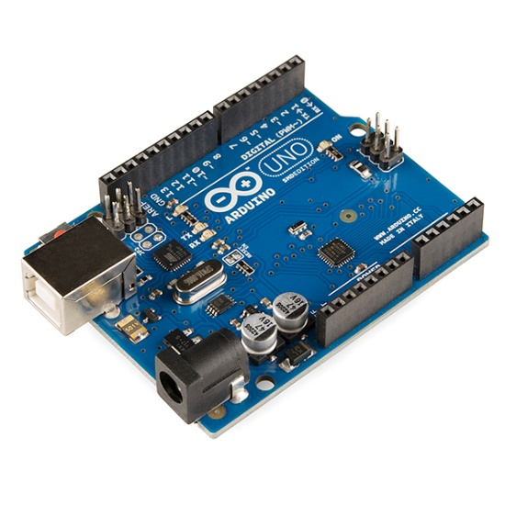

2. Ultrasonic Sensor (HC-SR04)

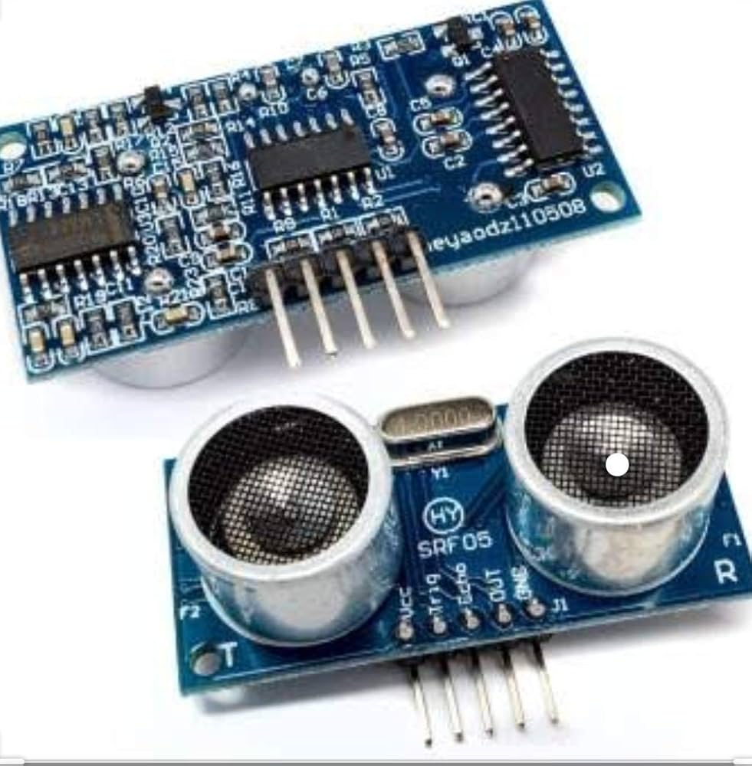

3. DC Motors

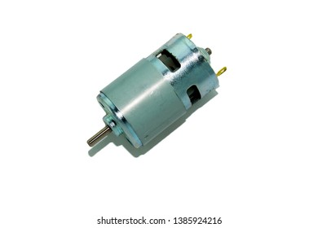

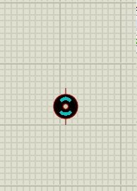

4. Motor Driver (L298N or equivalent)

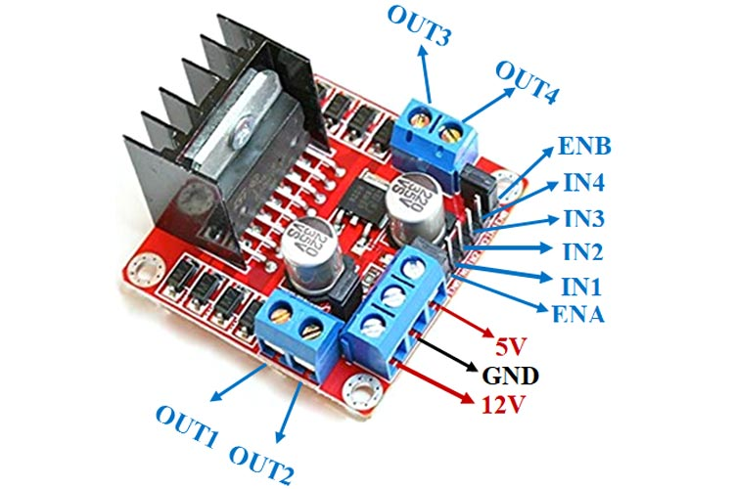

5. Chassis for the robot

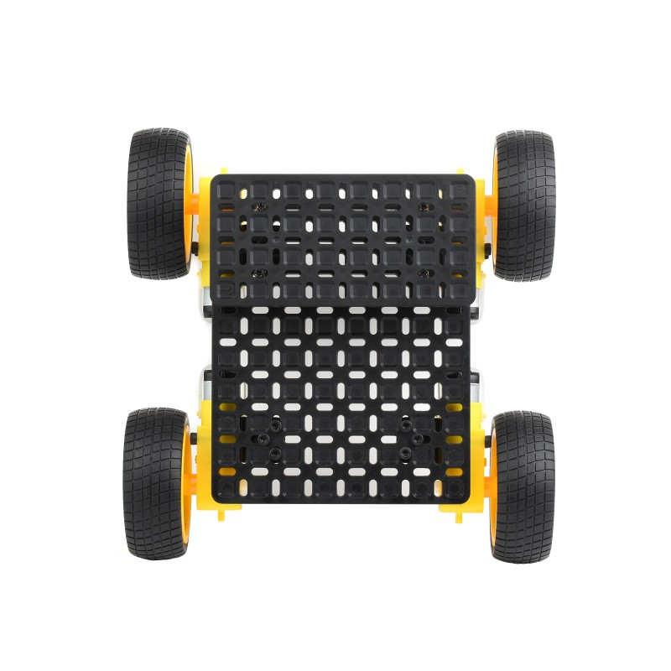

6. Caster wheel or support wheel

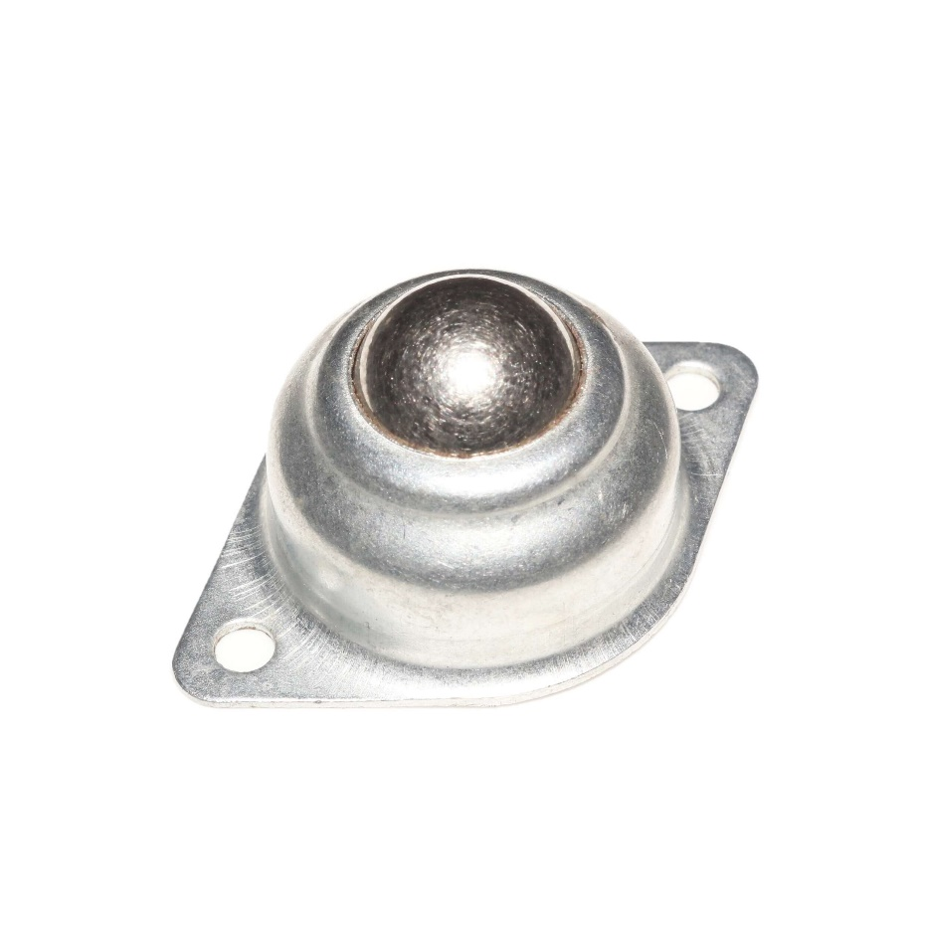

7. Power Source (battery pack)

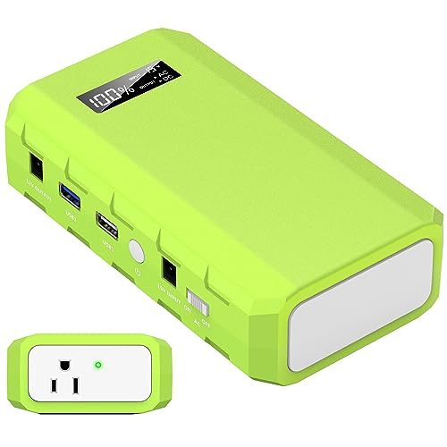

8. Jumper wires

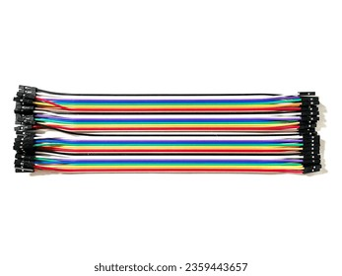

9. Breadboard (optional, for connections)

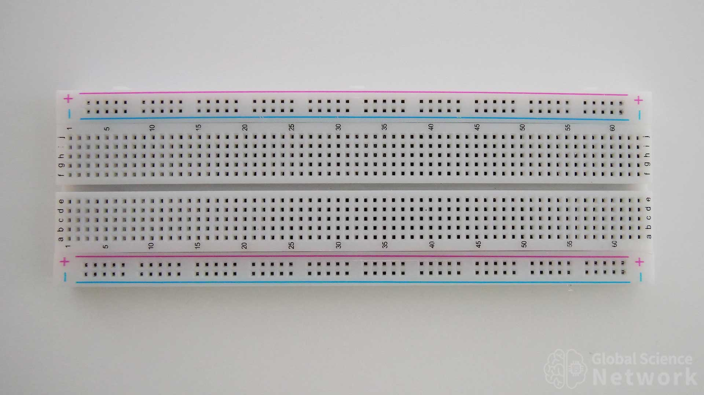

10. Potentiometer

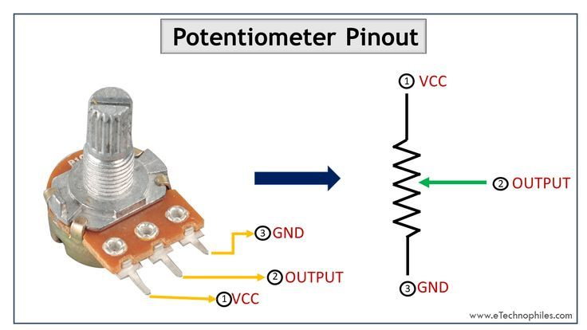

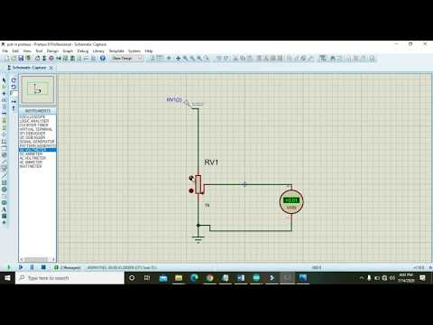

**Wiring Setup**

1. Ultrasonic Sensor (HC-SR04)

- VCC to 5V (Arduino)

- GND to GND (Arduino)

- TRIG to pin 9 (Arduino)

- ECHO to pin 10 (Arduino)

2. Motor Driver (L298N)

- Connect `IN1` to Digital Pin 3 (Arduino)

- Connect `IN2` to Digital Pin 4 (Arduino)

- Connect `IN3` to Digital Pin 5 (Arduino)

- Connect `IN4` to Digital Pin 6 (Arduino)

- Connect motors to `OUT1` and `OUT2` for one motor, and `OUT3` and `OUT4` for the other motor

- Connect `VCC` and `GND` of the motor driver to the battery

Below is the code we used using the Arduino UNO software:

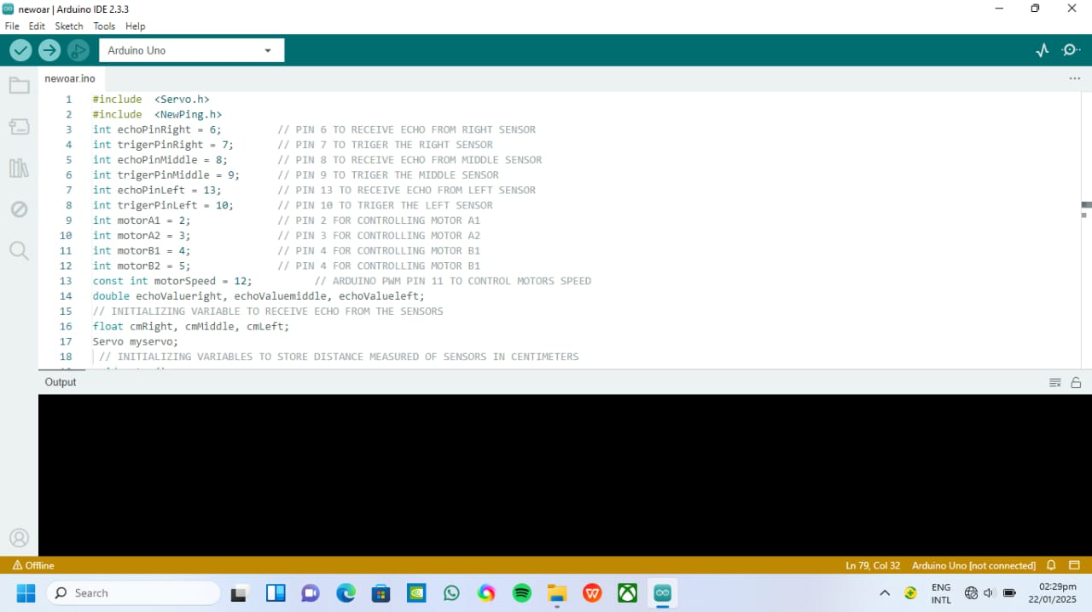

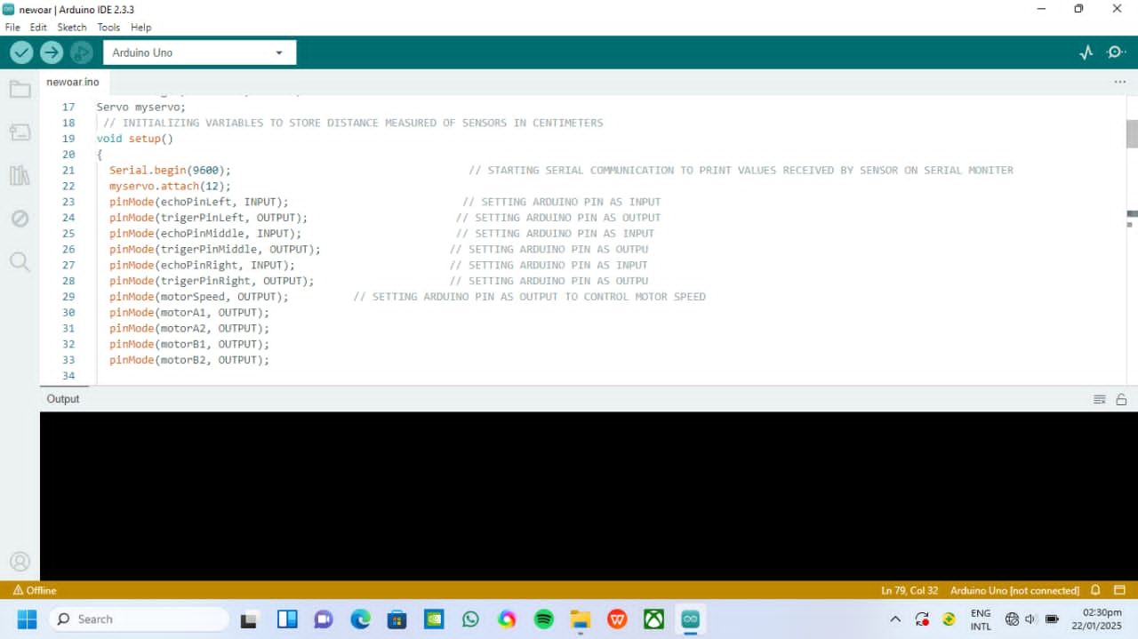

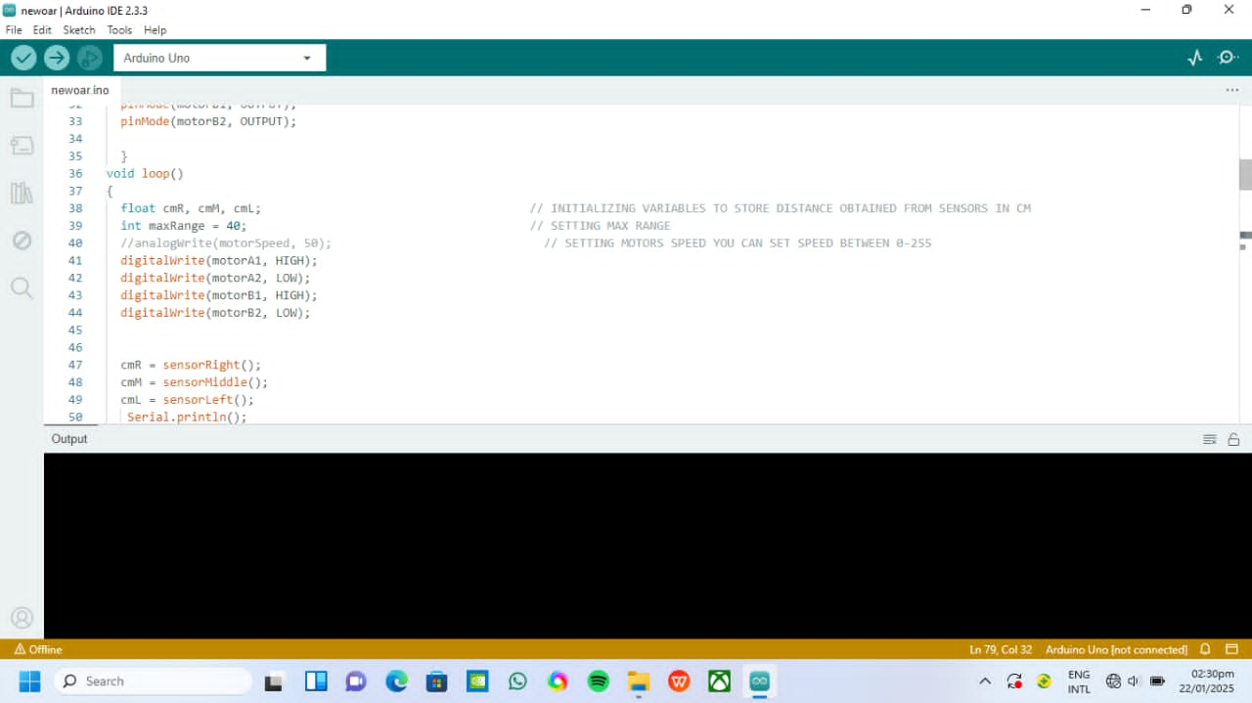

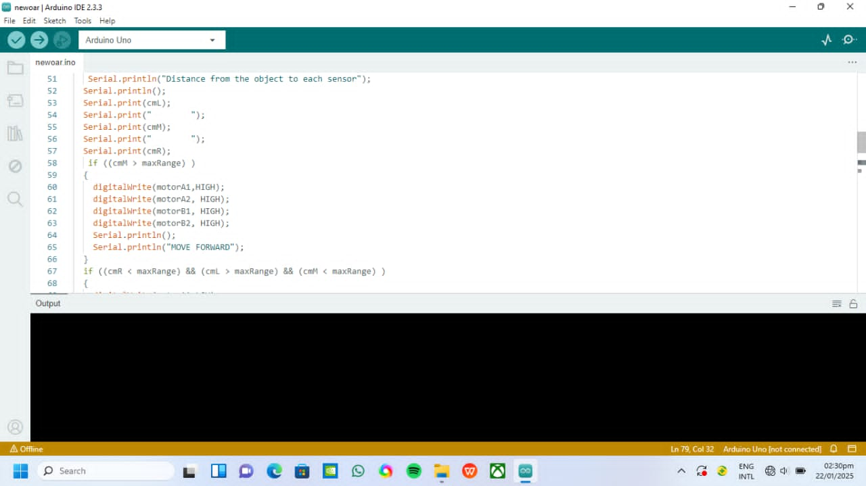

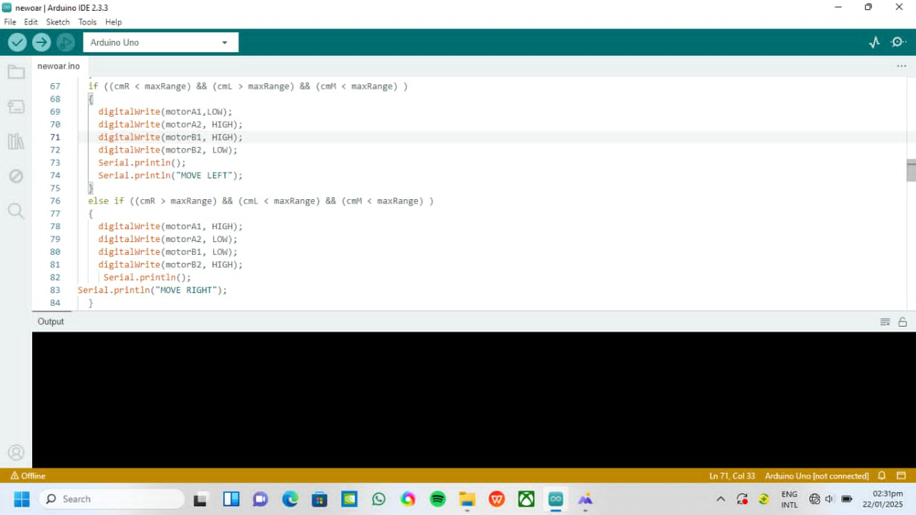

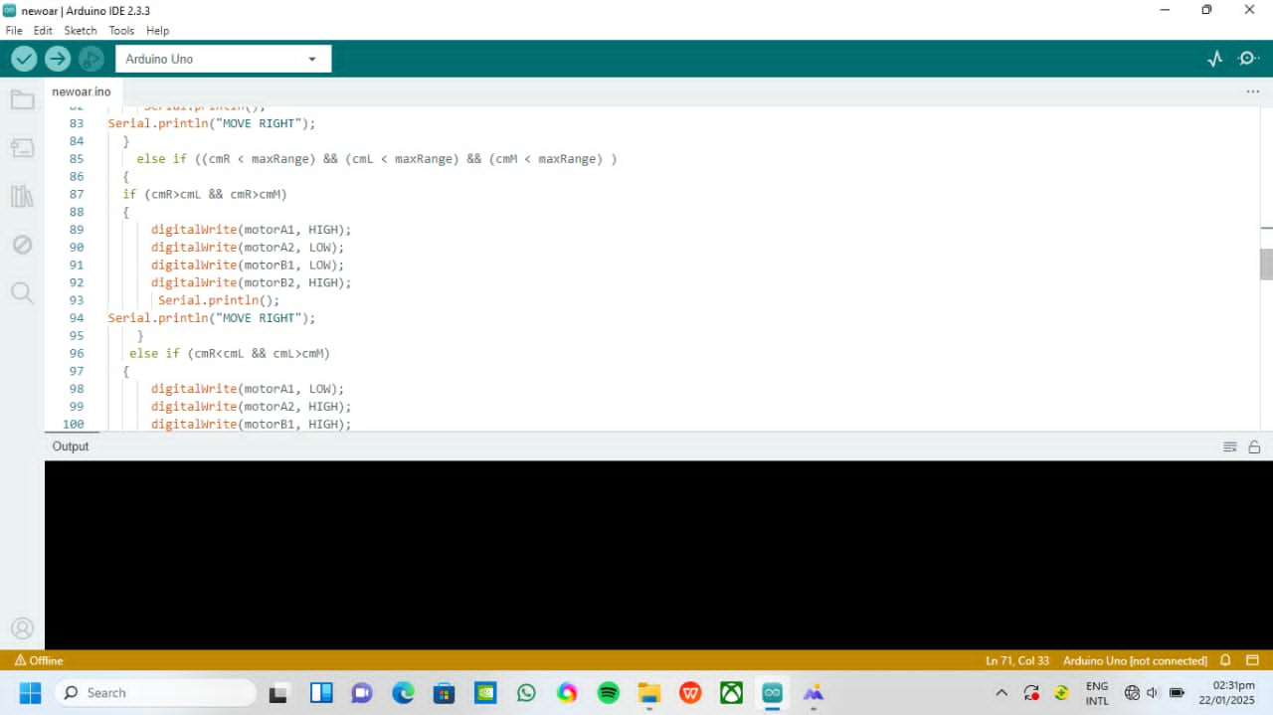

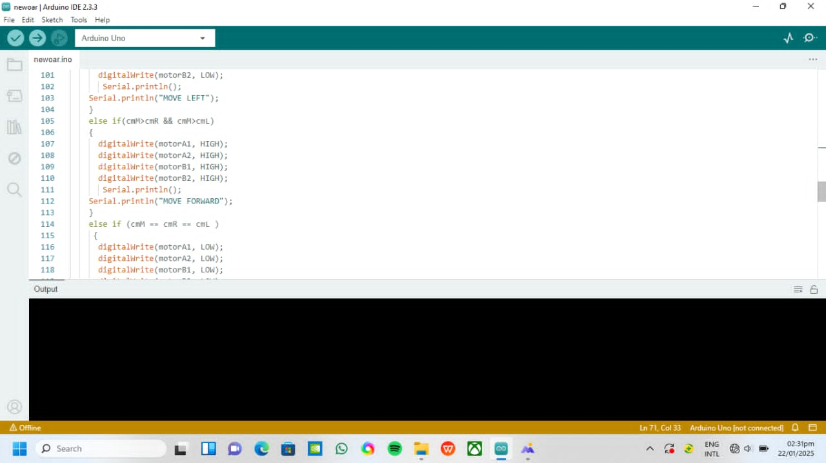

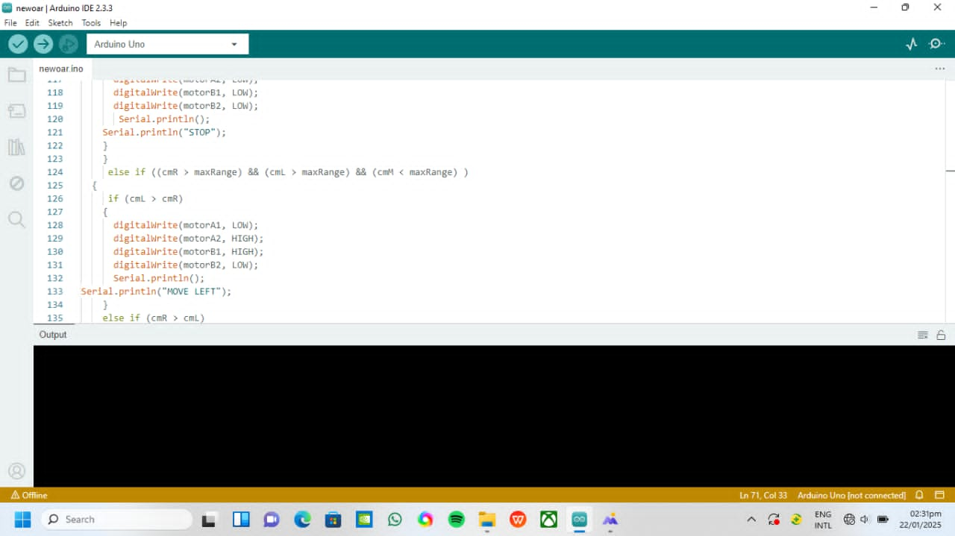

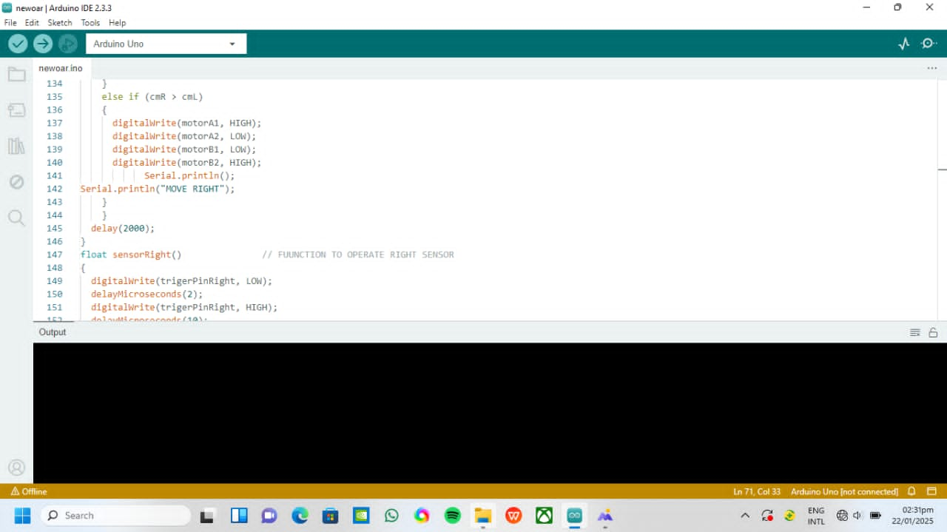

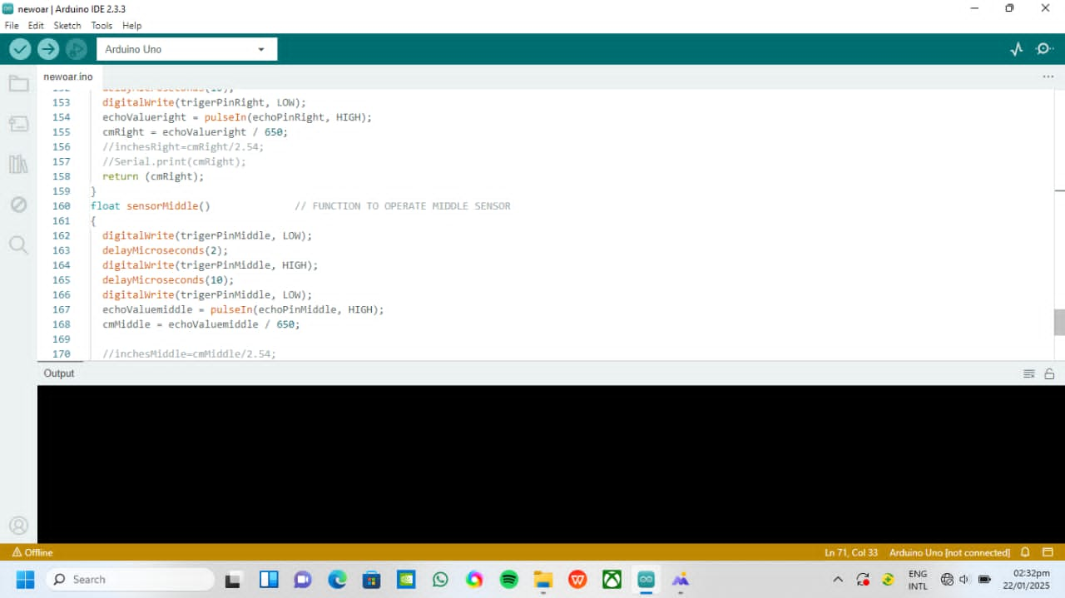

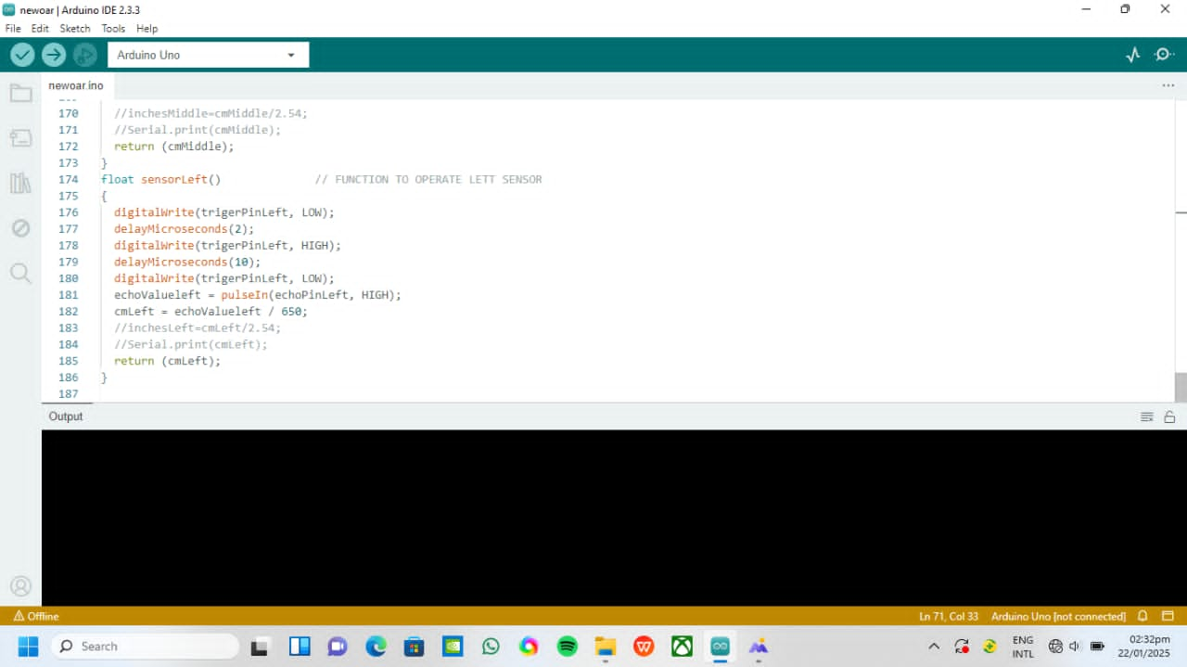

**B. Simulation of the robot in Proteus for testing**

Proteus is a powerful simulation software used for electronic circuit simulation and microcontroller-based projects. While Proteus is not primarily designed for detailed robotics simulation like some other software (e.g., Gazebo, V-REP, or Webots), it can still be utilized to simulate robotic control systems, including sensors, actuators, and microcontroller programming.

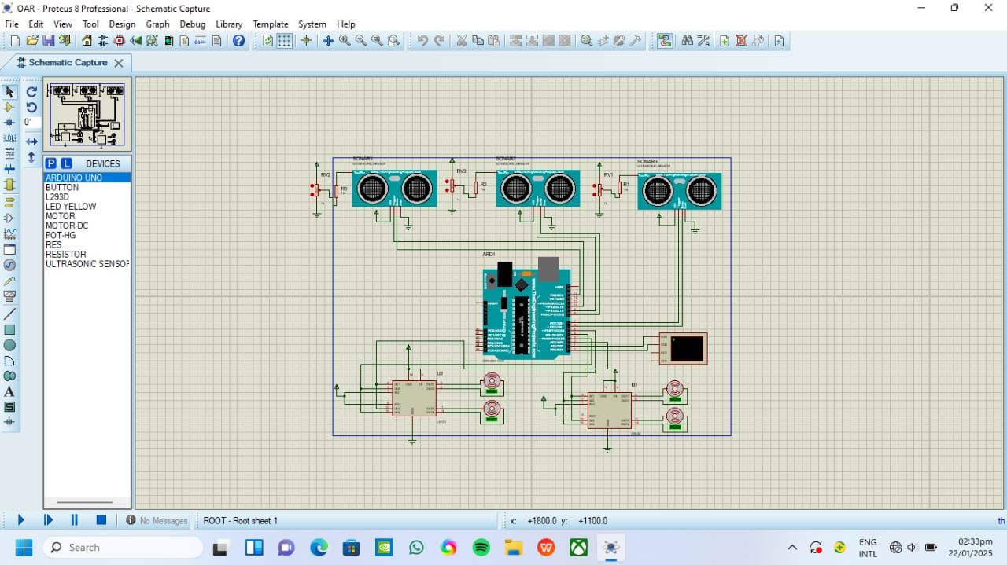

**Conclusion**

While Proteus is primarily used for simulating electronic circuits, it can effectively simulate simple robotic controls and systems. For more complex robotics simulations involving physical interactions in a 3D environment, consider using specialized robotic simulation software. However, Proteus is great for testing at the electronic and wiring level before implementation on actual hardware.

**C. Integration Of Sensor Data For Real-Time Obstacle Detection**

To achieve real-time obstacle detection, sensor data integration is crucial. This section covers a comprehensive approach to integrating sensor data from various sources, including ultrasonic sensors, cameras, lidar, and more. The goal is to create a robust and adaptive system that can detect obstacles in real-time, adapting to changing environments and conditions.

**1. Sensor Data Preprocessing**

Before integrating sensor data, it's essential to preprocess the raw data to ensure accuracy and reliability. This step involves:

a. Noise reduction: Remove random fluctuations or outliers from the data.

b. Data normalization: Ensure all sensor data is on the same scale for easy comparison.

c. Data filtering: Remove redundant or irrelevant data to reduce computational complexity.

**2. Real-time Data Processing**

Use efficient algorithms to process sensor data in real-time. Some common techniques include:

a. Kalman Filter: Combines data from multiple sensors to produce accurate state estimation.

b. Machine Learning: Train models to recognize patterns and anomalies in sensor data.

c. Computer Vision: Analyze images from cameras to detect objects and obstacles.

**3. Sensor Fusion**

Combine data from multiple sensors to create a more accurate and robust representation of the environment:

a. Multisensory Fusion: Combine data from various sensors (e.g., ultrasonic, lidar, and camera) to improve accuracy.

b. Federated Learning: Distribute machine learning models across sensors to create a centralized decision-making process.

**4. Real-time Obstacle Detection**

Implement algorithms to detect obstacles based on the integrated sensor data:

a. Object Detection: Identify objects within the environment using techniques such as YOLO (You Only Look Once) or SSD (Single Shot Detector).

b. Motion Detection: Detect moving objects or changes in the environment.

c. Collision Prevention: Predict potential collisions based on sensor data and take corrective actions.

**5. Adaptation to Changing Environments**

Ensure the system adapts to various environments and conditions:

a. Context-Aware: Adjust detection criteria based on contextual information (e.g., time of day, weather, etc.).

b. Machine Learning: Continuously learn from sensor data to improve detection accuracy and adapt to changing environments.

c. Sensor Self-Calibration: Regularly calibrate sensors to ensure optimal performance.

**6. Real-time Feedback and Control**

Implement a real-time feedback loop to adjust to changing environments and improve performance:

a. Sensor Feedback: Monitor sensor performance and adjust algorithms as needed.

b. System Feedback: Continuously evaluate system performance and adjust sensor fusion, object detection, and other algorithms to optimize results.

**Implementation**

The integration of sensor data can be implemented using various frameworks and platforms, such as:

1. ROS (Robot Operating System): A widely adopted software framework for robotics and sensor fusion.
2. TensorFlow: An open-source machine learning framework for implementing real-time obstacle detection and adaptation.
3. Computer Vision APIs: Utilize pre-trained models and libraries, such as OpenCV, to simplify object detection and recognition.

**3.3 CIRCUIT DESIGN**

**A. Schematic diagrams of the robot circuitry**

Creating a schematic diagram for your obstacle avoidance robot using an Arduino Uno, ultrasonic sensor (HC-SR04), and a motor driver (L298N) involves clearly illustrating how all electronic components are connected. Here’s a textual representation of how you can wire the components together. You can easily replicate this representation in an electronic circuit design software such as Fritzing, KiCad, or even as a hand-drawn schematic.

**Schematic Diagram Components**

1. Arduino Uno

2. HC-SR04 Ultrasonic Sensor

3. L298N Motor Driver

4. DC Motors (2)

5. Power Source (Battery)

6. Optional: LEDs (for indicators)

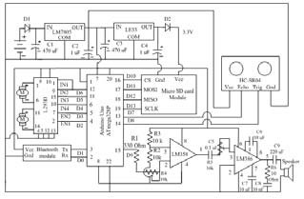

**B. Explanation of the connections between Arduino Uno, sensors, and motors**

Connecting the Arduino Uno to sensors and motors for an obstacle avoidance robot involves several key components: the Arduino itself, the ultrasonic sensor for distance measuring, and a motor driver to control the motors. Here’s a detailed explanation of how these connections work together and why they are set up this way.

**Components Overview**

1. Arduino Uno: Microcontroller that processes input from sensors and controls output to the motors.

2. Ultrasonic Sensor (HC-SR04): Measures the distance to obstacles by emitting ultrasonic waves and timing how long it takes for the echo to return.

3. Motor Driver (L298N): Allows the Arduino to control the direction and speed of the motors, handling the higher current requirements than the Arduino can supply directly.

**Connection Details**

1. **Ultrasonic Sensor (HC-SR04)**

a. VCC Pin: Connects to the 5V pin on the Arduino. This provides power to the sensor.

b. GND Pin: Connects to the GND pin on the Arduino. This completes the power circuit for the sensor.

c. TRIG Pin: Connects to a digital pin on the Arduino (e.g., Pin 9). This pin is used to send a signal to the sensor to start measuring distance.

d. ECHO Pin: Connects to another digital pin on the Arduino (e.g., Pin 10). This pin receives the time it takes for the ultrasonic pulse to return after hitting an obstacle.

The standard operation for the HC-SR04 is as follows:

1. The Arduino sends a HIGH signal to the TRIG pin for 10 microseconds.

2. This triggers the sensor to send out an ultrasonic pulse.

3. The sensor then waits for the echo to return and outputs a HIGH signal on the ECHO pin for the duration of this time, which is proportional to the distance. The Arduino measures this duration to calculate how far away an object is.

**2. Motor Driver (L298N)**

The motor driver allows the Arduino to control the direction and speed of the DC motors. Here’s how to connect it:

a. IN1 and IN2: Connect to two digital pins of the Arduino (e.g., Pin 3 and Pin 4) to control the first motor.

b. IN1: Turning this HIGH will rotate the motor in one direction.

c. IN2: Turning this HIGH will rotate the motor in the opposite direction.

d. IN3 and IN4: Connect to two other pins of the Arduino (e.g., Pin 5 and Pin 6) to control the second motor.

- Similar logic applies as above for controlling direction.

**Motor Outputs:**

1. OUT1 and OUT2: Connect to the terminals of the first DC motor.

2. OUT3 and OUT4: Connect to the terminals of the second DC motor.

**Power Connections:**

i. VCC (or +12V): Connect to the positive terminal of the battery or power source. This connection provides power to the motors.

ii. GND: Connect to the GND of both the battery and the Arduino to ensure a common ground.

**How Everything Works Together**

1. Sensor Input: The ultrasonic sensor measures the distance to obstacles. When an obstacle is detected within a certain threshold, it sends data to the Arduino.

2. Decision Making: The Arduino processes this data. If an obstacle is detected, it executes a predefined behavior (e.g., stopping, reversing, and turning).

3. Motor Control: The Arduino sends signals to the motor driver through IN1, IN2, IN3, and IN4 pins to control the speed and direction of the motors based on the decision made in the previous step.

4. Power: The motor driver takes care of supplying sufficient current to the motors, while the Arduino manages the control signals, ensuring that the entire circuit operates smoothly without overloading the Arduino’s pins.

**Summary**

In an obstacle avoidance robot using an Arduino:

- The HC-SR04 sensor measures distances and detects obstacles,

- The Arduino Uno processes this data and determines the movement strategy,

- The L298N Motor Driver controls the motors to execute these movements.

This setup constitutes a simple yet effective way of navigating around obstacles autonomously.

**C. Testing the circuit in Proteus for accuracy**

Testing your obstacle avoidance robot circuit in Proteus is a great way to simulate the functionality before building and testing the physical hardware. Here’s how to set up, simulate, and verify the accuracy of your circuit in Proteus.

**Step-by-Step Guide for Testing in Proteus**

**1. Circuit Design in Proteus**

a. Open Proteus: Start by launching the Proteus software.

b. Create a New Project: File > New Project, then follow the wizard to create a project in Proteus.

c. Place Components:

- Use the Components Mode to search for each component:

i. Arduino Uno

ii. HC-SR04 Ultrasonic Sensor

iii. L298N Motor Driver

iv. DC Motors (2)

v. Power Supply (Battery)

vi. Optional: LEDs for visual indication.

d. Wiring the Components: Use wires to connect the components as described in the previous messages. Ensure that:

The ultrasonic sensor is connected properly to the Arduino pins for TRIG and ECHO, and powered correctly.

- The motor driver inputs are connected to Arduino pins for motor control.

- The motors are connected to the motor driver outputs.

**2. Configure Component Properties**

a. Set Power Supply Voltage: Make sure the voltage supplied to the components is correct. For example, the ultrasonic sensor should be connected to a 5V supply, while the L298N may require a higher voltage depending on your motors (typically around 9-12V).

b. Adjust Motor Settings: If you're using DC motors from the library, ensure their parameters (like voltage and maximum current) match your expected values.

**3. Programming the Arduino**

a. Write the Code: You will need to write a simple Arduino sketch to control the motors based on the readings from the ultrasonic sensor. The code might look like this:

b. Importing the Code: You can import your Arduino code into Proteus by creating a hex file from the Arduino IDE (Sketch > Export Compiled Binary) and then linking this hex file to the Arduino in Proteus.

**4. Running the Simulation**

a. Start the Simulation: Click on the “Play” button (the green triangle) to start the simulation.

b. Monitor Outputs: Observe the behavior of motors and sensor readings in the virtual environment. You can use LEDs or voltmeters to check the signals at pins if necessary.

**5. Verification and Troubleshooting**

a. Check if the motors run when there are no obstacles and stop when an obstacle is detected within the threshold.

b. If the simulation doesn't behave as expected, verify the connections, check your code logic, and ensure all components are set up correctly.

c. Adjust component parameters or the code as needed based on the behavior you observe.

**Tips for Accurate Testing**

i. Simulate Different Scenarios: You can manually change the distance read by the ultrasonic sensor in Proteus to test how the robot behaves with varying distances.

ii. Use Virtual Instruments: Proteus offers tools like oscilloscopes and logic analyzers which can help you monitor signals and debug any issues in your circuit.

iii. Check for Power Supply: Ensure that your simulated power supply matches the specified voltage requirements for the components.

**Conclusion**

Testing your circuit in Proteus can help catch issues early in the design phase. Properly setting up your components, coding the Arduino, and simulating will give you a good indication of how the physical build will operate, helping you make adjustments before investing time in building the actual robot.

**CHAPTER 4**

**DESIGN AND SIMULATION OF AN OBSTACLE AVOIDING ROBOT USING MATLAB**

**Abstract**

In the realm of autonomous systems, obstacle avoidance is a fundamental challenge and a vital capability for robotic navigation. This project explores the design, development, and simulation of an obstacle-avoiding robot using MATLAB and Simulink. The system is designed with a differential drive model equipped with virtual ultrasonic sensors for detecting objects in the robot’s path. A reactive control algorithm processes sensor input to adjust the robot’s movement and avoid collisions. The entire simulation is performed using MATLAB’s Robotics System Toolbox, offering a rich visualization of the robot's behavior in a dynamic environment. This report details every aspect of the project, including literature context, design framework, algorithm development, simulation workflow, and evaluation of results. It concludes with a discussion on the system's performance and suggests possible improvements and future research directions.

**a. Introduction**

Robotics has emerged as a multidisciplinary field with applications ranging from manufacturing and agriculture to space exploration and domestic automation. A crucial aspect of autonomous robotic systems is their ability to sense and respond to their environment. Specifically, obstacle avoidance is a prerequisite for safe and efficient navigation.

Obstacle avoidance allows a robot to perceive the environment, detect potential hazards, and reorient its path dynamically to prevent collisions. Whether in structured indoor environments or unstructured outdoor terrains, the robot must interpret sensor data, process decisions, and actuate motors to maneuver efficiently.

This report describes the development and simulation of an autonomous obstacle-avoiding robot using MATLAB. The project utilizes virtual sensors, a differential drive model, and a simple yet effective reactive control algorithm to navigate a simulated 2D environment filled with static obstacles.

**b. Literature Review**

Numerous researchers have proposed methods for obstacle avoidance in mobile robots. Approaches vary from simple rule-based systems to complex machine learning models.

* **Bug Algorithms:** One of the earliest techniques used in robotics, where a robot moves toward a goal until it hits an obstacle, then follows its edge until it can resume its original direction [Latombe, 1991].
* **Potential Field Method:** Introduced by Khatib (1986), this method treats the robot as a particle moving in a field influenced by attractive (goal) and repulsive (obstacle) forces.
* **Fuzzy Logic and AI Methods:** These include neural networks, genetic algorithms, and fuzzy logic systems that enable adaptive navigation in complex environments [Zadeh, 1994].
* **Sensor-Based Reactive Systems:** These systems utilize real-time sensor input to adjust the robot’s trajectory without the need for complete environmental mapping [Brooks, 1986].

In this project, we focus on a reactive sensor-based system, combining simplicity and efficiency for real-time applications. MATLAB provides a rich environment for modeling, simulating, and visualizing robotic behaviors, making it ideal for this purpose.

**c. Objectives**

The primary objectives of this project are:

* To design a mobile robot capable of detecting and avoiding obstacles.
* To simulate the robot and its environment using MATLAB and Simulink.
* To implement a real-time reactive control algorithm based on sensor feedback.
* To evaluate the system’s performance in various simulated scenarios.

Secondary objectives include:

* Gaining proficiency with MATLAB’s Robotics System Toolbox.
* Demonstrating the integration of multiple subsystems (sensors, actuators, control logic).
* Visualizing robot motion and behavior using animation and plotting tools.

**d. System Architecture**

**1. Overview**

The robot comprises the following components:

* **Chassis:** A differential drive system with two independently controlled wheels.
* **Sensors:** Three virtual ultrasonic sensors positioned at the front, left, and right of the robot.
* **Controller:** A MATLAB function implementing decision-making logic based on sensor inputs.
* **Environment:** A simulated 2D space with randomly or manually placed static obstacles.

**2. System Flow Diagram**

**e. Tools and Technologies**

* **MATLAB R2023a+**: Core development platform.
* **Simulink**: Visual modeling of dynamic systems.
* **Robotics System Toolbox**: For kinematic modeling, simulation, and visualization.
* **Occupancy Grid Mapping**: For defining and interacting with a virtual 2D environment.
* **MATLAB Function Block / Stateflow**: For control logic implementation.

**f. Methodology**

**i. Robot Kinematic Model**

The robot is modeled as a differential drive system:

* Two independently driven wheels provide forward/backward motion and turning.
* Robot’s motion equations:
* *xt*+1​​=*xt*​+*v*⋅cos(*θ*)⋅Δ*t*
* ​*yt*+1​​=*yt*​+*v*⋅sin(*θ*)⋅Δ*t*
* ​*θt*+1​​=*θt*​+*ω*⋅Δ*t*​

Where:

* *v* = linear velocity
* *ω* = angular velocity
* *θ* = heading direction

**ii. Sensor Modeling**

* Three ultrasonic sensors simulate proximity detection:
  + **Front sensor**: detects obstacles directly ahead.
  + **Left/right sensors**: detect objects on respective sides.
* Sensor range: up to 3 meters.
* Simulated using line-of-sight checks within the occupancy map.

iii. **Environment Mapping**

* The environment is represented using a binary occupancy map:
  + 0 = free space
  + 1 = occupied (obstacle)

iv.  **Control Algorithm**

The control logic is reactive and based on current sensor readings:

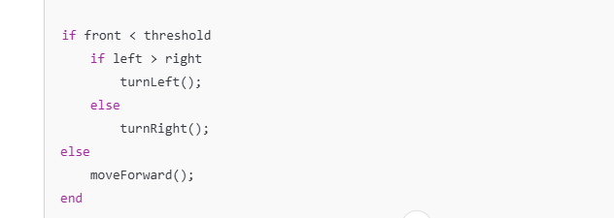

**g. MATLAB Simulation**

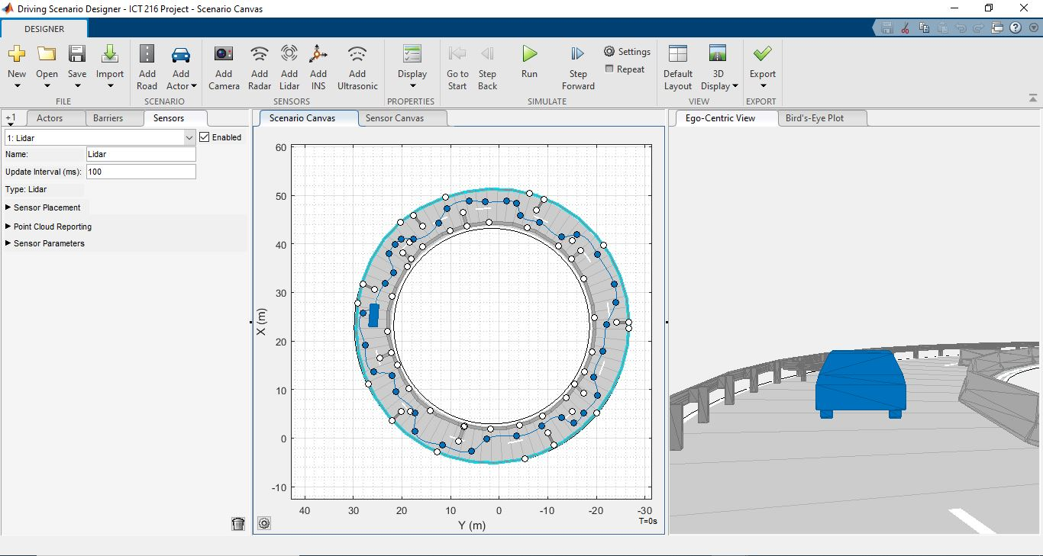

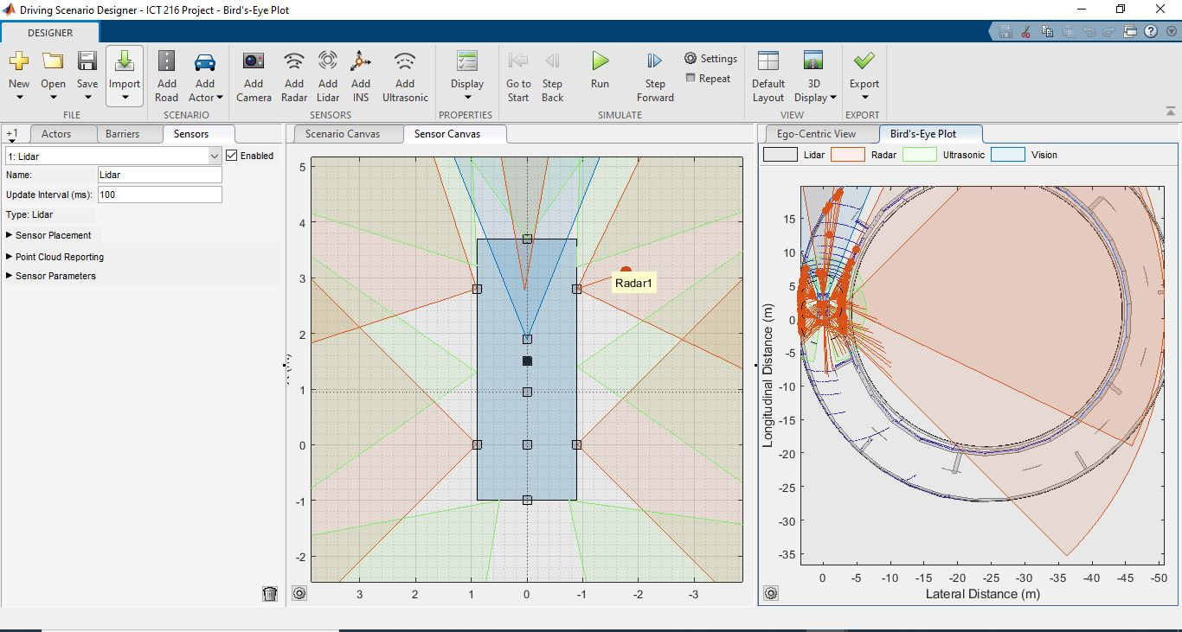

**Implementation Details**

**Environment Setup:**

map = binaryOccupancyMap(10, 10, 10);

setOccupancy(map, [5 5; 6 5; 5 6; 4 4], 1); % Obstacle placement

**Robot Setup:**

robot = differentialDriveKinematics('TrackWidth', 0.3, 'WheelRadius', 0.1);

pose = [1 1 0];

**Sensor Function:**

function dist = readSensor(pose, angle, map)

step = 0.1;

max_range = 3.0;

for r = 0:step:max_range

x = pose(1) + r*cos(pose(3) + angle);

y = pose(2) + r*sin(pose(3) + angle);

if getOccupancy(map, [x y]) > 0.5

dist = r;

return;

end

end

dist = max_range;

end

**Control Loop:**

for t = 0:0.1:20

front = readSensor(pose, 0, map);

left = readSensor(pose, pi/4, map);

right = readSensor(pose, -pi/4, map);

if front < 0.5

if left > right

v = 0.1;

omega = pi/4;

else

v = 0.1;

omega = -pi/4;

end

else

v = 0.3;

omega = 0;

end

vel = derivative(robot, [v omega]);

pose = pose + vel'*0.1;

show(map);

hold on;

plot(pose(1), pose(2), 'bo');

hold off;

pause(0.1);

end

**h. Results and Analysis**

The robot successfully navigated the environment and avoided all placed obstacles during simulation. Key observations include:

* **Efficient Reactivity**: The robot quickly responded to obstacles with minimal delay.
* **Path Deviation**: The reactive method sometimes caused zig-zag paths around clustered obstacles.
* **Limitations**: The lack of memory or mapping prevented the robot from optimizing its route.

Performance metrics:

|  |  |
| --- | --- |
| **Metric** | **Value** |
| Obstacle Collisions | 0 |
| Simulation Time | 20 s |
| Number of Turns | Variable based on obstacle layout |
| Average Speed | ~0.25 m/s |

**i. Challenges and Limitations**

* **Sensor Accuracy**: Simulated sensors do not reflect real-world noise and latency.
* **Reactive Nature**: Without global planning, the robot may enter loops in complex environments.
* **Environment Size**: Scalability to large maps is computationally intensive.
* **No Goal Detection**: The robot avoids obstacles but doesn’t move toward a target.

**j. Future Work**

* Integrate **SLAM (Simultaneous Localization and Mapping)** for environment mapping.
* Use **path planning algorithms** like A* or D* Lite for goal-oriented navigation.
* Apply **reinforcement learning** for adaptive control.
* Connect simulation to physical hardware using Arduino or Raspberry Pi.
* Introduce dynamic obstacles and implement collision prediction.

**k. Conclusion**

This project demonstrates a successful implementation of an obstacle-avoiding robot using MATLAB and Simulink. The system showcases the integration of sensing, control, and motion planning in a simulated environment. While the current model is reactive and lacks memory, it forms the foundation for more advanced autonomous systems. MATLAB's powerful visualization and toolboxes significantly aided in the modeling, simulation, and analysis of the robot’s behavior.

**CHAPTER 5**

**CONCLUSION**

**A. Summary of the project**

This project focuses on designing and building an autonomous obstacle avoidance robot that can navigate its environment by utilizing an Arduino Uno, an ultrasonic sensor (HC-SR04), and DC motors controlled via a motor driver (L298N). MATLAB was used to create the robot in 3D form and visualize it in a real-life scenario. Below is a summary of the key components, functionalities, and steps involved in the project.

**Project Objectives**

1. To create a robot that can identify and avoid obstacles using real-time distance measurement.

2. To demonstrate the integration of sensors, actuators, and a microcontroller in an autonomous mobile platform.

**Components Required**

1. Arduino Uno: The microcontroller used to process inputs and control outputs.

2. Ultrasonic Sensor (HC-SR04): Measures the distance to obstacles using ultrasonic waves.

3. Motor Driver (L298N): Controls the direction and speed of the DC motors.

4. DC Motors (2): Provide movement for the robot.

5. Power Supply: Battery or power source to power the components.

6. Chassis and Wheels: Structure to hold the components and provide mobility.

**Circuit Overview**

a. The circuit involves connecting the ultrasonic sensor to the Arduino for distance measurement, using digital pins for TRIG and ECHO.

b. The motor driver is connected to the Arduino's digital pins to control motor operations based on sensor readings.

c. Motors are connected to the motor driver outputs, allowing the Arduino to adjust direction and speed as needed.

**Functionality**

i. The ultrasonic sensor continuously measures the distance to the nearest obstacle in front of the robot.

ii. The Arduino processes the distance data. If an obstacle is detected within a defined threshold (e.g., 15 cm), the robot stops or changes direction.

iii. If no obstacles are detected, the robot moves forward.

**Programming Logic**

a. The Arduino sketch initializes the ultrasonic sensor and motor control pins.

b. In the loop function, the distance is measured, and based on this data, the robot decides whether to move forward or stop.

c. The speed and direction of the motors are controlled via PWM signals sent to the motor driver.

**Testing and Simulation**

1. Before physical implementation, the design is tested using Proteus for simulation.

2. The Arduino code is uploaded to the simulated Arduino in Proteus, where the circuit's functionalities are visually and operationally validated.

3. Various scenarios are simulated to ensure the robot behaves correctly with different distance readings.

**Conclusion**

This project showcases the intersection of programming, electronics, and robotics. By successfully implementing an obstacle avoidance robot, it provides hands-on experience in sensor integration, motor control, and microcontroller programming. The design can be further enhanced with advanced features such as adding additional sensors, incorporating machine learning for pathfinding, or improving battery life through efficient power management.

This project serves as a foundational step into the world of robotics, with numerous possibilities for expansion and development.

**B. Key findings and achievements**

**Key Findings**

**1. Sensor Accuracy and Range:**

a. The HC-SR04 ultrasonic sensor demonstrated reliable distance measurements, allowing the robot to effectively detect obstacles within its specified range (typically 2 cm to 400 cm).

b. Calibration and testing determined the optimal distance threshold (e.g., 15 cm) for obstacle avoidance, ensuring timely response to obstacles.

**2. Motor Control Dynamics:**

a. Using the L298N motor driver enabled precise control of motor direction and speed, proving essential for smooth operation.

b. Implementation of PWM (Pulse Width Modulation) for speed control allowed for adjustable speed settings, enhancing maneuverability.

**3. Integrated Circuit Functionality:**

a. Successful integration of various components (sensor, microcontroller, and motor driver) highlighted the importance of proper circuit design and connections.

b. Troubleshooting highlighted that minor wiring errors and incorrect pin assignments could lead to significant issues, emphasizing the need for careful planning and verification.

**4. Algorithm Performance:**

a. A simple control algorithm effectively managed dynamic obstacle avoidance, providing a foundation for more complex decision-making processes.

b. Real-time processing of sensor data allowed the robot to adjust its course promptly, preventing collisions and enabling navigation.

**5. Simulation Validity:**

a. Testing the circuit in Proteus before building the physical robot enabled early identification of potential issues, saving time and resources.

b. The simulation results closely matched expected outcomes, reinforcing confidence in the design and programming approach.

**Achievements**

**1. Successful Prototype Development:**

a. A fully functional obstacle avoidance robot was successfully developed and tested, meeting the primary project objective of autonomous navigation.

b. The robot effectively detects obstacles and maneuvers around them, demonstrating the core functionalities of obstacle avoidance.

**2. Hands-On Learning Experience:**

a. Gained practical experience in robotics, including soldering, component selection, wiring, and using CAD software for circuit design.

b. Enhanced understanding of microcontroller programming and the interplay between hardware and software in robotic systems.

**3. Implementation of Core Concepts:**

a. Successfully applied concepts of electronics (resistances, voltage, current) and programming (loops, conditionals) in a real-world application.

b. Developed skills in using Integrated Development Environments (IDEs) for coding and debugging Arduino programs.

**4. Foundation for Future Projects:**

a. Established a foundational knowledge base that can be expanded upon for future robotics projects, such as adding advanced sensors (camera, LIDAR) or implementing machine learning algorithms.

b. Documentation of the project provides a valuable reference for similar future endeavors, fostering continued learning and innovation.

**5. Potential for Enhancement:**

Identified areas for improvement, such as optimizing the power supply for better battery life, adjusting mounting positions of sensors for improved accuracy, and incorporating communication modules for remote operation.

**Conclusion**

The obstacle avoidance robot project has yielded significant insights into robotics and embedded systems. Through careful design, simulation, and testing, the project achieved its objectives and provided practical learning experiences that can inform future developments in the field. The combination of theoretical knowledge and hands-on application solidifies understanding of robotic principles and paves the way for more complex projects.

**C. Future work and potential enhancements**

As robotics technology advances, the importance of obstacle avoidance will continue to grow, driving research and development in areas such as:

**1. Advanced Sensors:** Improving sensor technologies for better detection and recognition of obstacles.

**2. Artificial Intelligence (AI) and Machine Learning (ML):** Enhancing robots' decision-making capabilities through AI and ML, enabling them to adapt to new situations and learn from experiences.

**3. Human-Robot Interaction:** Developing robots that can safely interact with humans, recognizing and responding to human movements and intentions.

**CHAPTER 7**

**REFERENCES**

**1. Arduino Documentation:**

Arduino. (n.d.). *Arduino Reference*. Available at: [https://www.arduino.cc/reference](https://www.arduino.cc/reference)

This official documentation provides comprehensive information on programming the Arduino and using various components.

**2. Ultrasonic Sensor (HC-SR04) Documentation:**

Adafruit. (n.d.). *HC-SR04 Ultrasonic Distance Sensor*. Available at: [https://learn.adafruit.com/ultrasonic-range-finder-hc sr04](https://learn.adafruit.com/ultrasonic-range-finder-hc-sr04)

This resource gives an overview of the ultrasonic sensor's specifications, wiring, and usage example.

**3. Motor Driver (L298N) Documentation:**

SparkFun Electronics. (n.d.). *L298N Dual H-Bridge Motor Driver – COM-13262*. Available at: [https://learn.sparkfun.com/tutorials/l298n-dual-h-bridge-motor-driver](https://learn.sparkfun.com/tutorials/l298n-dual-h-bridge-motor-driver)

This tutorial explains the functionality and characteristics of the L298N motor driver and provides guidance on how to use it with motors.

**4. Robotics Books:**

Poole, D., & Mackworth, A. (2010). *Artificial Intelligence: Foundations of Computational Agents*. Cambridge University Press.

This book provides theoretical insights into AI principles relevant to robotics, including decision-making and sensor integration.

**5. Online Tutorials and Courses:**

Coursera and Udemy offer various robotics and Arduino courses that can enhance understanding and provide practical experience in building autonomous systems.

Example course: *Robotics: Aerial Robotics* – available on Coursera.

**6. YouTube Tutorials:**

Many robotics enthusiasts and educators publish step-by-step guides for creating obstacle-avoiding robots using Arduino, which provide visual and practical instruction.

Channels like "GreatScott!" and "Paul McWhorter" focus on electronics and Arduino projects.

**7. Research Papers and Journals:**

IEEE Xplore and other academic databases contain numerous papers on robotics and autonomous systems, which can provide deeper insights into topics such as obstacle avoidance algorithms and sensor fusion.

**8. Corke, P. (2017). *Robotics, Vision and Control:***

Fundamental Algorithms in MATLAB. Springer.

**9.** Siegwart, R., Nourbakhsh, I. R., & Scaramuzza, D. (2011). Introduction to Autonomous Mobile Robots. MIT Press.

**10.** The MathWorks, Inc. (2023). Robotics System Toolbox Documentation. <https://www.mathworks.com/products/robotics.html>

**11.** Khatib, O. (1986). Real-Time Obstacle Avoidance for Manipulators and Mobile Robots. International Journal of Robotics Research.

**12.** Latombe, J. C. (1991). Robot Motion Planning. Springer.

**13.** Zadeh, L. A. (1994). Fuzzy Logic, Neural Networks, and Soft Computing. Communications of the ACM.

**14.** Brooks, R. A. (1986). A Robust Layered Control System for a Mobile Robot. IEEE Journal on Robotics and Automation.